**STATE CHART DIAGRAM & ACTIVITY DIAGRAM**

**HU22CSEN0100999**

**ESHWAR DESHMUKH CHAVAN**

**State Chart Diagram in UML**

* A **State Chart Diagram** (also called a **State Machine Diagram**) is a **behavioral UML diagram**.
* It represents different states of an object and shows transitions based on specific events.
* Helps analyze the **dynamic behavior** of a system and defines object lifecycles.

**State Chart Diagram Notations**

State Chart Diagrams use **UML symbols** to represent states and transitions:

1. **States**
   * Represented as **rounded rectangles**.
   * Each state defines a **specific condition** of an object.
   * Example: **Active, Inactive, Processing**.
2. **Initial State**
   * Depicted as a **filled black circle**.
   * Marks the **starting point** of the state machine.
3. **Final State**
   * Shown as a **black circle with an outer ring**.
   * Represents the **end of the process**.
4. **Transitions**
   * Illustrated with **arrows connecting states**.
   * Show how an object **changes states** when an event occurs.

**Example: ATM System State Chart Diagram**

**States in an ATM System:**

* **Idle** – ATM is ready to accept user input.
* **Card Inserted** – User inserts a card.
* **PIN Verification** – System verifies the entered PIN.
* **Transaction Selection** – User chooses a transaction type.
* **Processing Transaction** – ATM processes the selected transaction.
* **Transaction Complete** – Transaction finishes, and the card is ejected.
* **Error State** – After repeated incorrect PIN entries, the ATM locks the card.

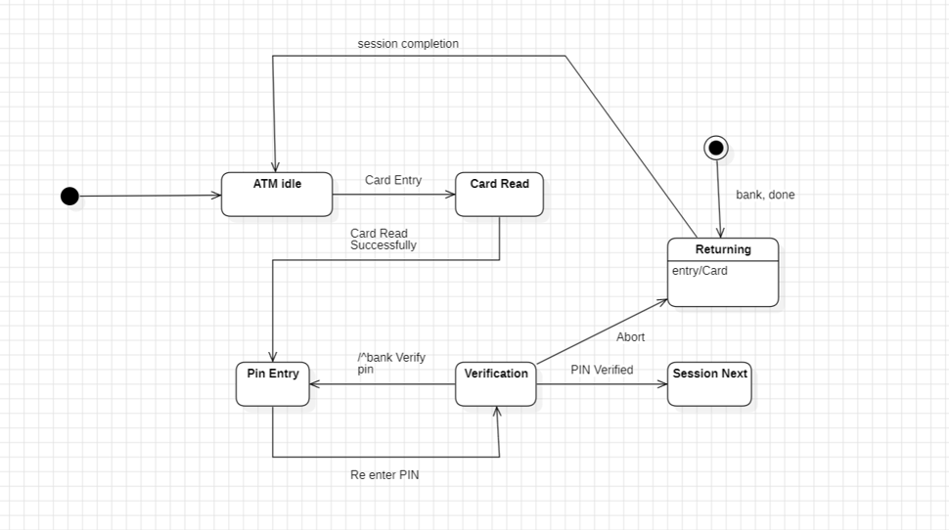

**Transitions in ATM System**

* **Idle → Card Inserted** – When the user inserts their card.
* **Card Inserted → PIN Verification** – After the user enters their PIN.
* **PIN Verification → Transaction Selection** – If the PIN is correct.
* **PIN Verification → Error State** – If the PIN is entered incorrectly multiple times.
* **Transaction Selection → Processing Transaction** – After the user selects a transaction.
* **Processing Transaction → Transaction Complete** – If the transaction is successful.
* **Transaction Complete → Idle** – The ATM resets to idle after transaction completion.

**Example: University Student State Chart Diagram**

**States:**

* Application Submitted → Application Under Review → Approved/Rejected → Enrollment Completed → Graduation

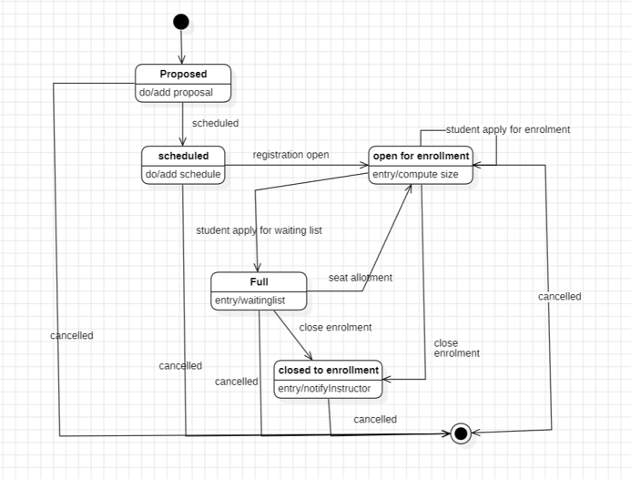

**Transitions in University Student State Chart Diagram**

* **Application Submitted → Application Under Review** – The university begins evaluating the application.
* **Application Under Review → Approved/Rejected** – The application is either accepted or denied.
* **Approved → Enrollment Completed** – If approved, the student completes the enrollment process.
* **Enrollment Completed → Graduation** – After fulfilling academic requirements, the student graduates.

**Activity Diagram in UML**

* An **Activity Diagram** is a **behavioral UML diagram** that represents the **flow of activities** in a system.
* Focuses on **procedural flow and control logic**, showing the **sequence of operations** rather than object states.

**Activity Diagram Notations**

Activity Diagrams use **specific UML symbols** to represent workflows and decision-making:

1. **Initial Node**
   * Marks the **starting point** of the activity flow.
   * Represented as a **filled black circle**.
2. **Activity (Action) Nodes**
   * Represent **specific tasks or operations** in the workflow.
   * Depicted as **rounded rectangles**.
   * Example: **Submit Form, Make Payment**.
3. **Decision Node**
   * Represents a **conditional choice** in the process.
   * Shown as a **diamond shape**.
   * Example: **Is PIN Correct? Yes → Continue, No → Retry**.
4. **Merge Node**
   * **Combines multiple paths** into a single flow.
5. **Fork and Join Nodes**
   * **Fork** – Splits the flow into **multiple parallel** paths.
   * **Join** – Merges parallel paths **back into a single flow**.
6. **Final Node**
   * Represents the **end of the activity flow**.
   * Depicted as a **black circle with an outer border**.

**Example: University Student Enrollment Activity Diagram**

**Actors & Their Roles:**

* **Student** – Registers, enrolls in courses, checks grades.
* **Admin** – Approves or rejects student registrations, manages courses.
* **Teacher** – Evaluates and grades student work.

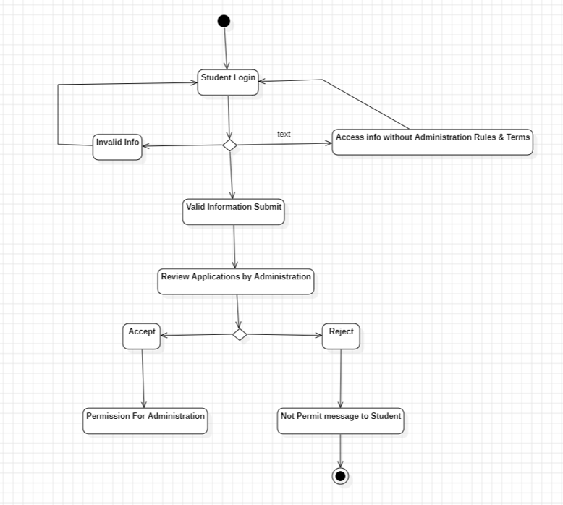

**Workflow: University Student Enrollment Activity Diagram**

1. **Student Registers** → **Initial Node** (Start of the process).
2. **Admin Reviews Registration** → **Decision Node (Approved/Rejected)**.
3. **If Approved** → **Student Logs In** → **Enrolls in Course**.
4. **If Rejected** → **Process Ends**.
5. **Student Attends Course**.
6. **Teacher Assigns Grades**.
7. **Student Checks Grades**.
8. **Process Ends** (Final Node)

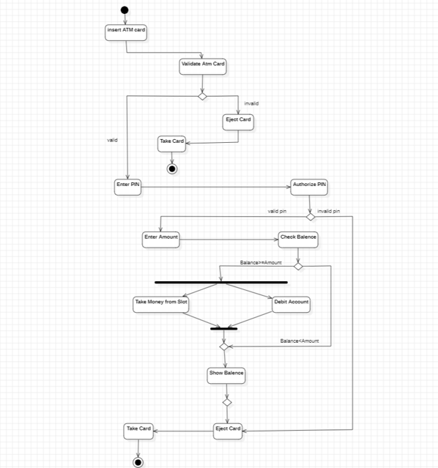

**Example: ATM System Activity Diagram**

**Actors & Their Roles:**

* **Customer** – Inserts card, enters PIN, selects a transaction.
* **ATM System** – Verifies PIN, processes transactions, dispenses cash.

**Workflow:**

1. **Customer Inserts Card** → **Initial Node** (Process starts).
2. **ATM Requests PIN** → **Decision Node (Correct/Incorrect)**.
3. **If Correct** → **User Selects Transaction**.
4. **If Incorrect** → **Retry or Block Card (After multiple failures)**.
5. **Transaction Processed** → **Cash Dispensed**.
6. **Card Ejected** → **Process Ends** (Final Node).